ISM War Room Strategy — Team Panem
15–16 April 2026 | Derrick Teo | Year 1 Playbook v5

North Star — Year 1
Commit $600K to the Line factory as early as possible. Everything in Year 1 is subordinated to this single goal. Three phases — EARN, BORROW & BUILD, COMPOUND — are gated on the $600K Line milestone. Year 2+ topics (Hero derivatives, Attack product, Cell, bilateral trade, container shipping) live in the tactical sections below but are not phase events in Year 1.

Starting Constraint
Starting cash $549K. Line factory total $600K ($100K land + $500K capex). Cannot build Line on Day 1. Pilot Bench produces ~9–10 units/day. Cell ($3M) and new DC ($2.6M) out of reach. Emergency loan 40% APR — avoid.

Core Insight
The lever is NOT organic cash growth. It is: (1) immediate WTP-indexed pricing on existing Bench output, (2) one clean quarter of EBIT to unlock bonds at ≤15% APR, (3) Line built from bond proceeds starting Day 95.
Critical Phase 1 discipline: NO advertising and NO extra focus groups before Line construction starts. Bench cannot fulfill ad-driven demand. A single stockout breaks the Bass imitator flywheel permanently.

Year 1 Execution Timeline
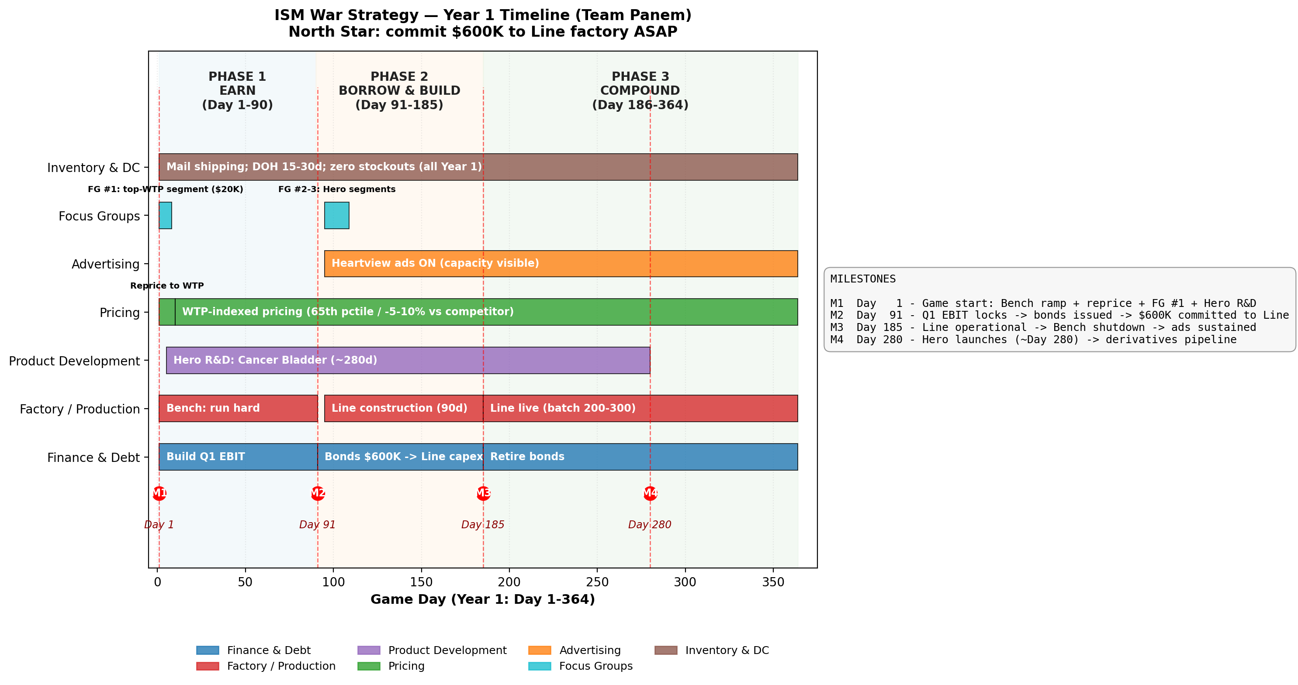
Figure 1. Year 1 timeline across Day 1–364. Three phases gated on the $600K Line milestone.

Team Roles — One Primary, One Backup
Three symmetric pairs. Each person has one primary role and one named backup. The backup covers if the primary is out and co-owns the work area. Partners resolve disputes laterally — Derrick is pulled in only for pricing or phase-transition calls.
Person | Role | Backup | Owns | Lateral Partners
Derrick Teo | CEO + Pricing | Jack Meng | Pricing calls. Overall strategy. Phase transitions. Scoreboard. | Jack (WTP), Jason (competitor prices), Chris (cash impact)
Jack Meng | Product Dev & Focus Groups | Derrick Teo | New product design, FG scheduling, WTP data, R&D pipeline. | Derrick (WTP), Chris (R&D cost), Shiyuan (feasibility)
Chris Ma | CFO — Finance | Jason Weng | Cash runway, bonds, tax, debt model, capex approval, DSO. | Shiyuan (capex), Jason (DSO), Jack (R&D cost)
Jason Weng | Competitor + Shipping Agreements | Chris Ma | Daily competitor intel. Bilateral trade contracts. | Derrick (price signals), Yohei (competitor stockouts), Chris (DSO)
Shiyuan Tian | COO — Production | Yohei Nakadate | Factory K/L, batch size, idle-time, unit cost, upgrade timing. | Yohei (throughput), Chris (capex), Jack (feasibility)
Yohei Nakadate | Inventory & Supply Chain | Shiyuan Tian | DOH targets, ROPs, mail vs container, stockout watch. | Shiyuan (production), Jason (competitor stockouts)

Symmetric pairs (covers for each other): Derrick ⇄ Jack • Chris ⇄ Jason • Shiyuan ⇄ Yohei

Lateral Resolution — How Disputes Get Solved
Default rule: resolve between partners without going to Derrick. Derrick is pulled in only for pricing calls or phase transitions.
- Batch size / ROP: Shiyuan + Yohei decide. Yohei owns stockout risk.
- Capex timing: Shiyuan + Chris decide against cash constraint.
- DSO on a new agreement: Jason + Chris decide against WC ratio.
- New product feasibility: Jack + Shiyuan + Chris. Final proposal to Derrick.
- Stockout emergency: Yohei pulls brake → Shiyuan reprioritizes. No approval needed.
- Ad spend envelope: Chris + Derrick set at phase transitions. Jack executes.
- Competitor price reaction: Jason flags → Derrick reprices (pricing = Derrick).
- Pricing logic or phase transition: Derrick decides. Partners provide data.

Daily Operating Cadence
- Start of session (10 min): Chris = cash/EBIT/runway. Jason = competitor moves. Yohei = stockout risk.
- During play: Derrick reprices. Shiyuan runs factory. Yohei adjusts ROPs. Jack briefs Derrick when FG data lands.
- End of quarter: Chris posts tax reserve + debt issuance. 10-min retro.

PHASE 1 — EARN (Day 1–90)
Goal: Generate Q1 EBIT to unlock cheap bonds at Day 91. Nothing else matters in Phase 1.

Day 1 — Parallel Moves
- Shiyuan: crank Bench daily L. Batch ~100. Never drop L near $0.
- Derrick: reprice Heart Monitor to best-known WTP immediately.
- Jack: fire ONE focus group ($20K) on highest-WTP reachable segment. Results Day 8.
- Jack: start Hero R&D (Cancer Bladder, ~280 days).
- Chris: open Debt Model. Project Q1 EBIT. Find threshold for Excellent (20×) vs Good (7×).
- Jason: baseline all competitors — product, price, DC, capacity. Log daily.
- Yohei: ROP > 0 on all agreements. Mail shipping. DOH 15–30 days. Watch Inventory Status daily.

Day 8–90 — Execute
- Derrick: reprice precisely once FG #1 data lands (Day 8). Own market = 65th pctile WTP. Contested = 5–10% below competitor median.
- Yohei: DOH 15–30. Zero stockouts. Same-region shipping only.
- NO advertising. NO more focus groups. NO dividends. NO new DC or factory.
- Chris: daily cash runway. Cash ≥ (quarterly tax + 1 month opex). WC ratio ≥ 1.0.
- Jason: flag any competitor Line build — their capacity lands +90 days from their start.

PHASE 2 — BORROW & BUILD (Day 91–185)
Goal: Issue bonds. Build the Line. Turn ads on.
- Day 91 — Q1 EBIT locks. Chris confirms rating. Target Excellent (10%) or Good (15%).
- Day 91–95 — Chris issues bonds. $600K minimum (Line); $1M if R&D/WC buffer needed.
- Day 95 — Shiyuan starts Line construction ($500K K + $100K land, 90 days to operational).
- Day 95 — Derrick + Jack turn Heartview ads ON ($500/day baseline).
- Day 95–185 — Bench continues. Clone shipping agreements to the future Line.
- Day 95–185 — Jack fires FG #2 and #3 on Hero derivative segments.

PHASE 3 — COMPOUND (Day 186–364)
Goal: Line live. Cash compounds. Retire bonds. Hero launches.
- Day 185–190 — Line operational. Batch 200–300. Bench shutdown scheduled ~10 days after first Line batch.
- Day ~280 — Hero (Cancer Bladder) launches. Begin Hero derivative designs for adjacent high-WTP segments.
- Chris: begin bond retirement from retained earnings. Maintain interest coverage > 7×.
- Jason: evaluate opening bilateral trade with allies once Hero exists.
- Yohei: keep mail shipping throughout Year 1 (container era is Year 2+ when throughput ≥150/d).
- Jack + Shiyuan: evaluate Attack product R&D (Military/Serenity) if Hero on schedule.

Pricing & Advertising Rules
- Own / uncontested market: Price at 65th percentile of segment WTP.
- Contested market: Price 5–10% below competitor median. Advertise to capture imitator share.
- Heartview ads: OFF until Day 95. Then sustained. Taper when A/M > 80%.
- Ad spend math: $500/day ≈ +1p innovator rate. NEVER advertise without fulfillment capacity.
- Never cost-plus: Cost sets walk-away floor only.

Finance — Debt & Capital Allocation
- Target APR: ≤15% (Excellent or Good). 40% emergency = failure.
- Rating tiers: Excellent ≥20× (10%). Good ≥7× (15%). Poor ≥2× (25%). Coverage = yearly EBIT / total interest.
- Issuance timing: Day 91 post-Q1. Engineer EBIT up BEFORE issuance.
- 364-day compounding: EAR = (1 + APR/364)^364 − 1.
- Year 1 CAPEX order: (1) Line $600K → (2) ads post-Day-95 → (3) Hero R&D → (4) bond retirement. Everything else waits.
- WC float: Materials 30d, others 15d. ≈$100–150K free float.
- No dividends Year 1: Dividends 6.5% after-tax < 10–15% bond APR. Retire debt first.

Year 2+ Tactics (parked, not Year 1 phases)
These are tactical playbooks for post-Day-364 execution. Do not pursue in Year 1 unless the $600K Line milestone is already locked and cash allows.
- Hero derivatives: Target ADJACENT segments, not same-segment-same-region (cannibalization). Cheaper R&D, faster launch.
- Attack product: Military / Serenity. Botulinum / anatoxin-a / sarin / cyclosarin. Only exists in military region.
- Container shipping: Trigger: throughput ≥150/d AND batch 500–1500. DOH 28–35d. $5K/$10K per container, up to 1,000 units.
- Bilateral trade: Once Hero range exists. Price 2–5% below ally median WTP. Half-CM split. Early: batch 20 / ROP 20 mail. Mid: batch 50–80 / ROP 50–80.
- Buying from Cell: Once any team has Cell, buy cheaper than our Line makes. Jason + Shiyuan MUST know MOH formula.
- Cell factory: $3M K. Evaluate only after fresh bondable capacity supports it.
- Feature discipline: Never put Hero features into a lower-WTP product — cannibalizes Hero margin.

Quick Reference — Key Numbers
Item | Value
Starting cash | $549K
Line factory total | $600K ($100K land + $500K capex)
DC total | $2.6M + $2K/day + fulfillment
Sales commission (retailer) | 20%
Handling (retailer) | $10/unit
Mail same-region (we pay) | $200/shipment (10 units)
Mail inter-region | $400/shipment
Container same-region | $5K / 1,000 units / 7d
Container inter-region | $10K / 21d
Innovator rate p | 0.0002
Imitator rate q | 0.0035 (≈17× p)
Ads: +1p cost | $500/day
Emergency loan | 40% APR (AVOID)
Bond tiers | 10% @ 20× / 15% @ 7× / 25% @ 2×
Tax rate | 35% × quarterly op income
Compounding base | 364 days/year
Q1 / Q4 / Q12 | Day 91 / 364 / 1,092
Bench | A=0.009, α=0.10, β=0.85, setup 0.05d
Line | A=0.010, α=0.30, β=0.75, setup 0.50d, K ≥ $500K
Cell (Year 2+) | A=0.020, α=0.80, β=0.30, setup 1.0d, K ≥ $3M
Post-tax CM | (price − MOH − W3 − price·comm) × (1−tax), W3 = materials + shipping + handling

Traps to Avoid
- Advertising before Line construction starts — Bench stockout breaks Bass flywheel permanently.
- Burning $60K on three FGs Day 1 — one is enough for Phase 1.
- 40% emergency loan — always a planning failure.
- DC in Year 1 — $2.6M kills the bond story.
- Inter-region shipping in Phase 1 — 2× cost, no upside yet.
- Same-segment same-region cannibalization.
- Dropping Bench L to "save cash" — factory locks; can brick.
- Bonds before Q1 EBIT registers — rating stuck at Poor (25%).
- Dividends in Year 1 — negative carry vs bond APR.
- Advertising a saturated market (A/M > 80%).
- Hero features in a low-WTP product.
- Shipping agreements without MOH formula in hand.
- Routing every dispute through Derrick — use lateral partners.

Open Decisions for Team
- Region — Metropolis (large + 4 military) vs non-military?
- FG #1 target — Cancer Bladder (highest WTP) or Clinical Cardio (larger market)?
- Bond sizing Day 91 — $600K (Line only) vs $1M (Line + R&D buffer)?
- Ad budget post-Day-95 — $500/day or $1,000/day?
- Role acknowledgement — each owner + backup explicitly accepts before Day 1?

Scoreboard — What We Optimize
Final rank = Return to Investors, Retained Earnings, Cash Position.
• Return to Investors = cash − debt + dividends paid + after-tax return on dividends distributed
• Retained Earnings = sum of net earnings − dividends declared
• Cash Position = cash − emergency loan
Bonds temporarily depress Return to Investors but unlock Line throughput that grows all three after retirement.

